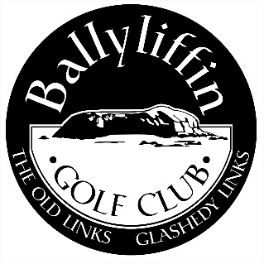
Application for Full Membership 2024

NAME

ADDRESS

TEL.NO. (HOME) …………………… (MOBILE) ………………………………

(BUSINESS) …………………. (EMAIL) ……………………………........

D.O.B. …………………… Gender (Female/Male) …Local / Non-Local (please circle)

CURRENT CLUB.…………………… HANDICAP ……………………………….

CONTACT DETAILS.………………… GUI ……………………………...

METHOD OF PAYMENT Cheque Cash Visa/Mastercard

Credit Card No: __________________________Exp. Date: _________CVV_________

PROPOSED BY _____________________________Membership No. _________

SECONDED BY _____________________________Membership No._________

Signature ___________________________________ Date ____________________

Ballyliffin Golf Club, Ballyliffin, Inishowen, Co. Donegal, Ireland
Tel: 074 93 76119 * International Calls: 00353 74 * info@ballyliffingolfclub.com * www.ballyliffingolfclub.com
Applications must be Proposed & Seconded by a Full Adult Member or Lady Associate Member of 5 years standing.

Full Membership Rules 2024

Entrance fees and conditions for membership are subject to review by the council of Ballyliffin Golf Club and should be confirmed should application be successful.

Open to Ladies & Gents. (Excludes Levies)

LOCAL €1100 Initial Subscription € 1100.00 FIXED FOR FOLLOWING 4 YEARS.

NON-LOCAL €1400 Initial Subscription € 1400.00 FIXED FOR FOLLOWING 4 YEARS.

All members must spend a minimum amount per annum on their club Swipecard. This is currently set at €100 and subject to change.

Residency:

Applicants must be permanently resident in the locality for a minimum of 6 months when making an application for membership under the category ‘Local Member’ as defined by the club.

Proof of permanent residency may be sought and would include:
Utility bills, tax affairs, electoral register & vehicle registration.
Local Full Membership

Initial Subscription €1100
Golf Ireland Levy €28
Insurance €25
Members Swipe €100
€1253

The ‘Initial Subscription’ will be paid on joining. The following 4 years will be fixed at €1100 per year. Fees will revert to the normal Full Subscription in year 6.
Non-Local Full Membership

Initial Subscription €1400
Golf Ireland Levy €28
Insurance €25
Members Swipe €100
€1553

The ‘Initial Subscription’ will be paid on joining. The following 4 years will be fixed at €1100 per year. Fees will revert to the normal Full Subscription in year 6.

